Chapter 3: Water

3.1 Water can change state

Literacy support worksheet answers (pages 48–49)

The state we’re in

1 Complete the flow chart below using Figure 3.4 in the student book to revise the states of water.

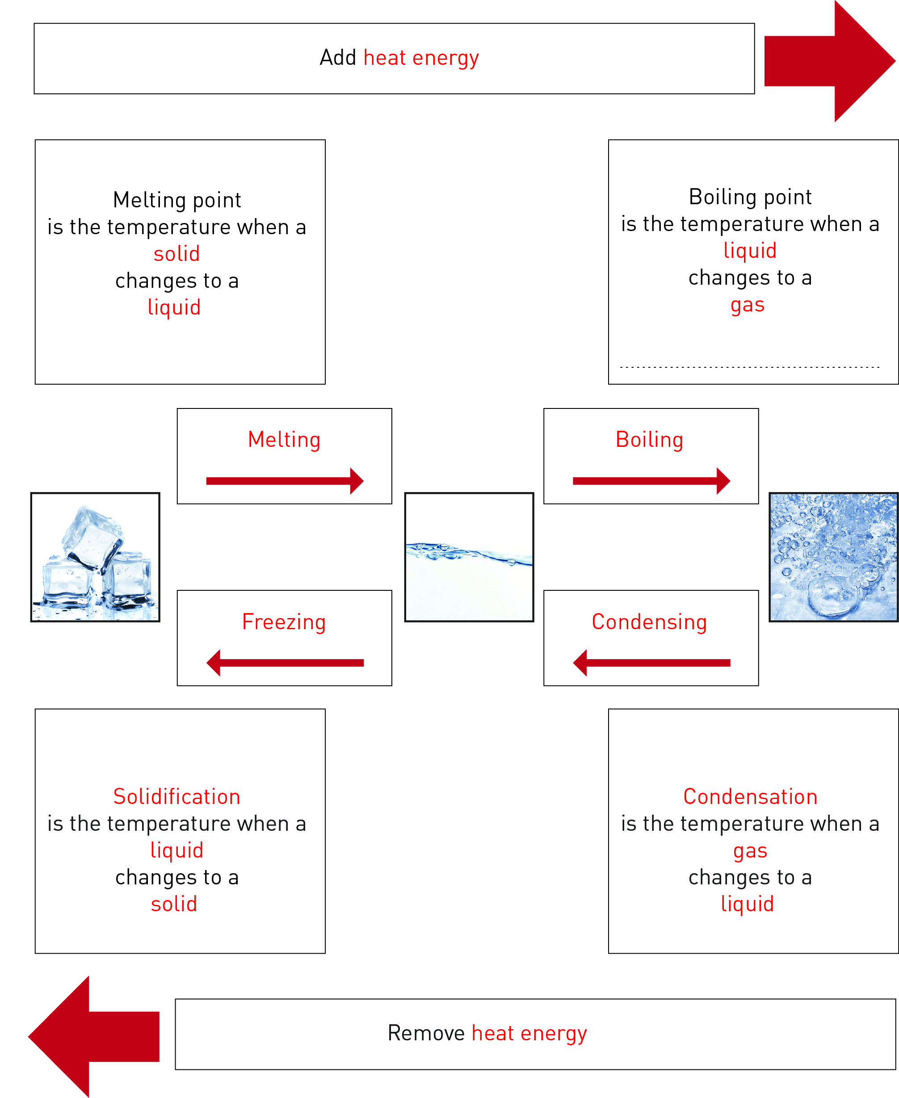

2 After completing the ‘Three States of Water’ experiment, label the diagram below to identify the *processes* causing the changes of state.

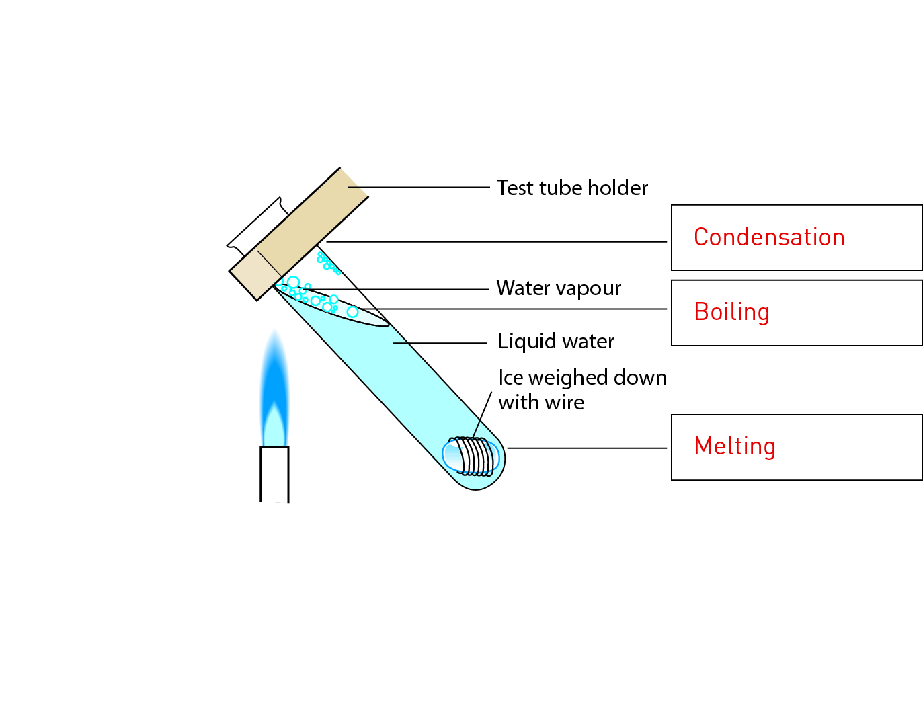

3 Fill in the state in the spaces provided belowusing the following words: *steam*, *water*, *ice*.

a ice + heat = water

b steam – heat = water

c water – heat = ice

d water + heat = steam

4 Fill in the process that leads to the change of state in the space provided.

a When you add heat to ice you are melting the ice.

b When you add heat to water you are boiling the water.

c When you cool water you are freezing (solidifying) it.

d When you remove heat from steam, you causing condensation.

WORD DETECTIVE

5 Secret message

Use words from the student book to work out the secret message below:

CONDENSATION IS WHEN A GAS CHANGES TO A LIQUID

3.2 Water cycles through the environment

Literacy support worksheet answers (pages 50–51)

Riding with H2O – The water cycle

1Complete the flow chart below on the water cycle.

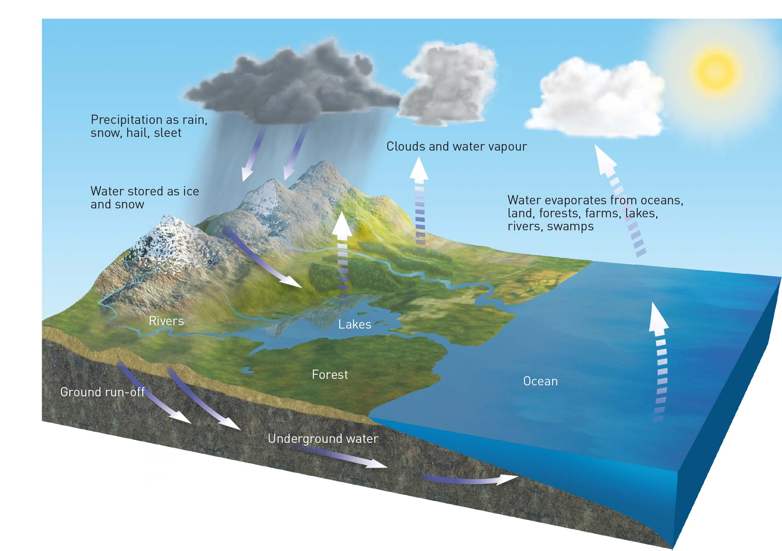

2 What does the Sun do in the water cycle?

The Sun provides the heat energy required to melt ice and snow to produce water.

The Sun also provides the heat energy required to evaporate water to produce water vapour, which can become clouds.

3 Name the changes of state during the water cycle in the spaces below:

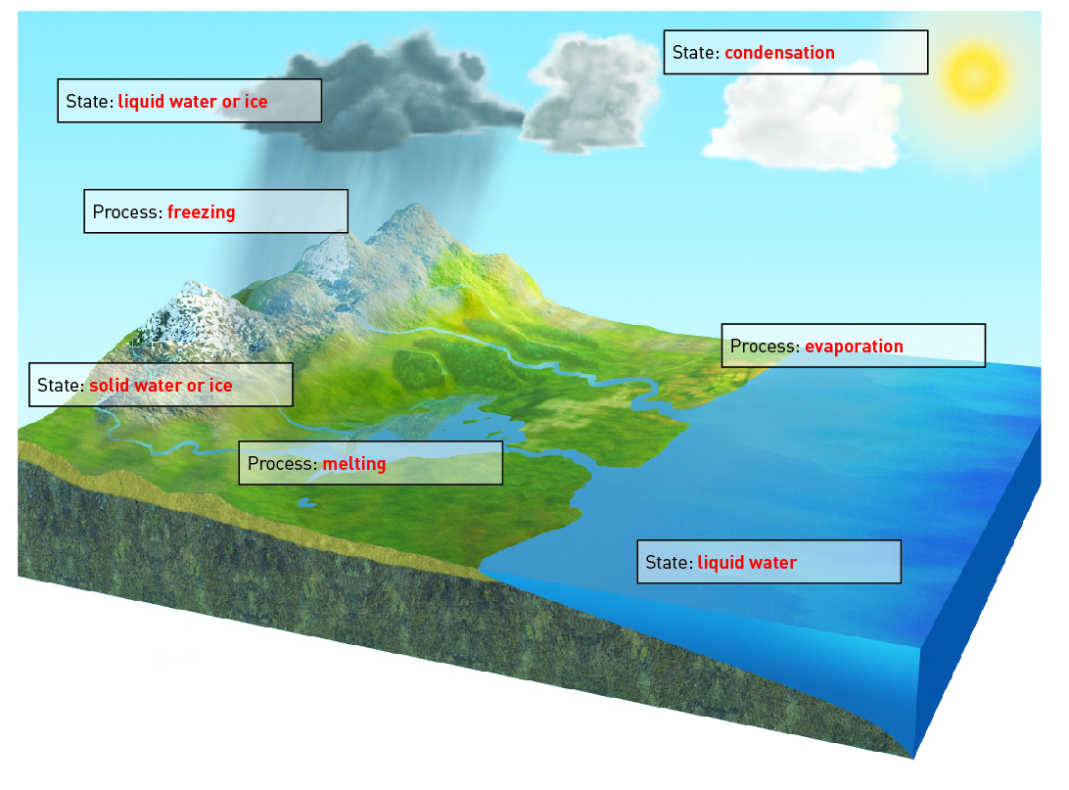

WORD DETECTIVE

4 Quick quiz

Answer the following questions using the list of words below:

a What is another name for water vapour?

steam

b When water drops form on the inside of a car, it is called:

condensation

c What is solid water called?

ice

d When you put on aftershave or perfume and it disappears, it has:

evaporated

e What is the name for when the water from plants evaporates?

transpiration

f When clouds form water droplets and they fall to Earth, it is called:

precipitation

Now design your own quick quiz for a friend.

3.3 Factors in nature affect the water cycle

Literacy support worksheet answers (pages 52–53)

Land of droughts and flooding rains

1 The diagram below shows the processes of El Niño. Look at the colour coding on the diagram and which states of matter exist in the air and the ocean, then fill in the boxes.

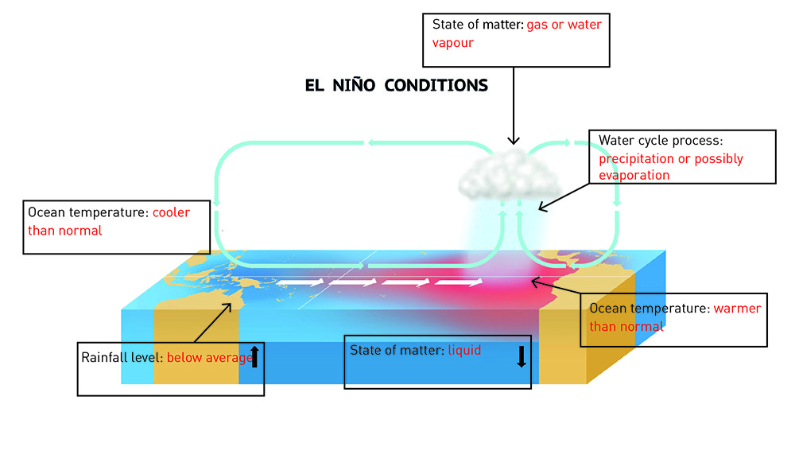

2 Describe how El Niño affects Peru. This is different to how it affects Australia.

El Niño causes higher than average rainfall in Peru because of the warmer than normal ocean temperatures.

3 Describe how La Niña affects Peru

La Niña causes lower than average rainfall in Peru because of the lower than average ocean temperatures.

4 The diagram below shows the processes of La Niña. Look at the colour coding on the diagram and which states of matter exist in the air and the ocean, then fill in the boxes.

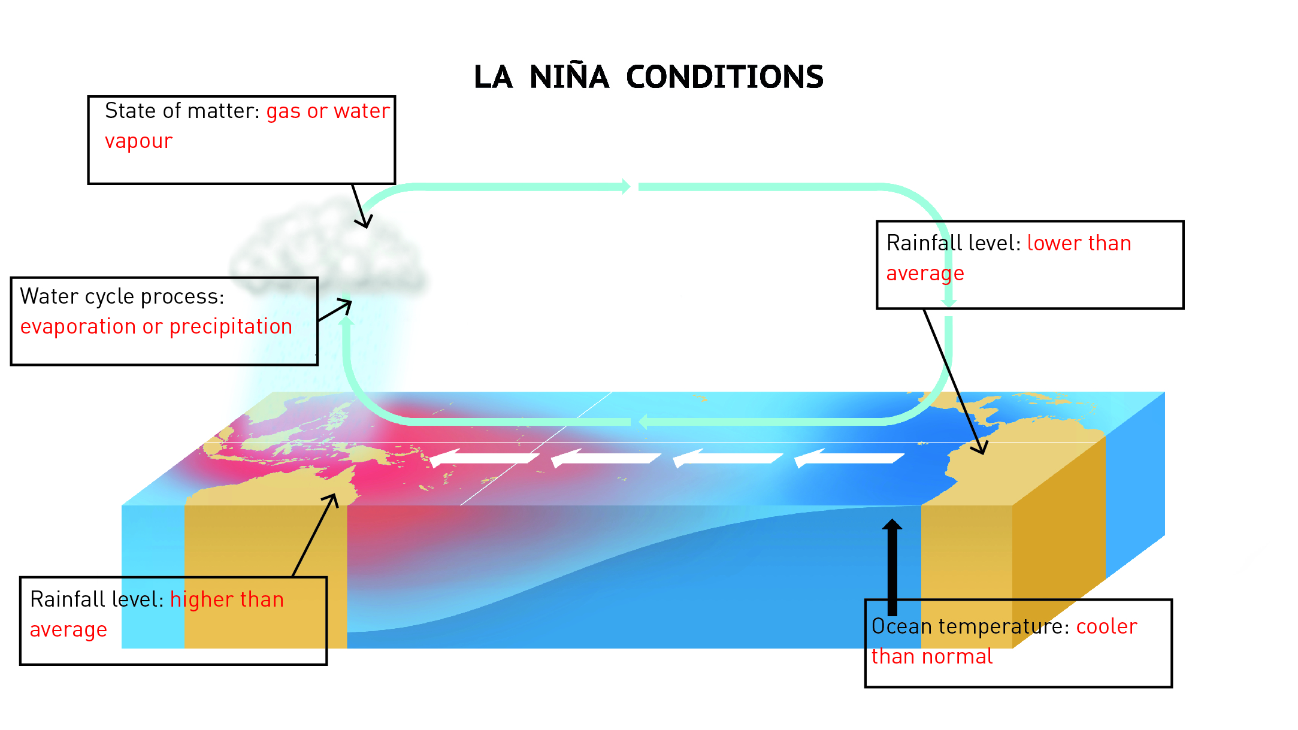

WORD DETECTIVE

5 Mumbo-jumbo

a Use the marked letters to find the secret word (e.g. olusntoi = solution).

b Unscramble each of the clue words below to find the message.

Secret word: CLIMATE

E

M

Message: EL NIÑO EVENTS WARM THE PACIFIC OCEAN

3.4 Human management affects the water cycle

Literacy support worksheet answers (pages 54–55)

What’s the use of water?

1 Approximately 65% of the water we use in Australia is used for agriculture and farms.

a What other purposes is water used for in Australia?

Other uses for water in Australia include: mining (2%), manufacturing (3%), sewage and drainage (11%), domestic (12%), electricity and gas (1%) and other industry (6%).

b In the table below, write two pros and two cons of using water for agriculture.

|  |  |
| --- | --- |
| Pro of using water for agriculture | Con of using water for agriculture |
| Higher production of food | Pollution from farms can flow into rivers |
| Crops grow more quickly and are better quality | Less water available for the environment |

2 Industry causes the emission of pollution as a result of the burning of fossil fuels. This pollution has been linked to changes in weather patterns and global warming. If pollution from burning fossil fuels mixes with the water vapour in the clouds, it can cause acid rain. How can acid rain affect humans, dams and plants?

This could affect the quality of the water for human use, and it could contaminate dams and damage plants and crops.

3 The Thomson Dam and the Warragamba Dam are marked on the cropped image from the map in the textbook.

a Which city would use the Thomson Dam for part of its domestic water supply?

Melbourne would use the Thomson Dam for its water supply.

b Which city would use the Warragamba Dam for part of its domestic water supply?

Sydney would use the Warragamba Dam for its water supply.

WORD DETECTIVE

4 Match-a-word

Match the words to their meanings.

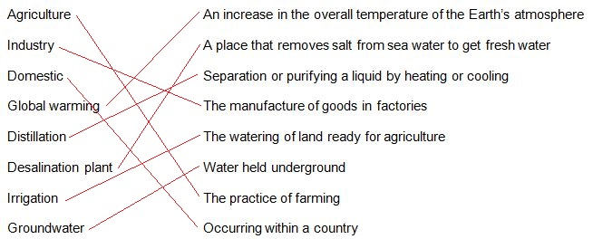

3.5 Science as a human endeavour: Water is a precious resource

Literacy support worksheet answers (pages 56–57)

There’s precious little water

1 If the world’s water was represented by a 1 litre (1000 millilitre) container, calculate the number of millilitres for the following categories:

a Salt water = 97.5% × 1000 mL = 975 mL

b Fresh water = 2.5% × 1000 mL = 25 mL

2 The amount of water available per person on Earth is estimated to be 222 billion litres. Using Figure 3.19 in the textbook as a guide, complete the table below.

|  |  |  |
| --- | --- | --- |
| Location of water | Amount of water available per person (litres) | % Total water |
| Total water on Earth | 222 billion | 100 |
| Fresh water on Earth | 2.5% x 222 billion = 5.55 billion | 2.5 |
| Liquid (not frozen) fresh water on Earth | 0.75% × 222 billion = 1.67 billion | 0.75 |
| Fresh water in lakes and rivers | 0.025% × 222 billion = 0.06 billion | 0.025 |

a Look at the graph on the right. What percentage of water is for domestic (personal use)?

12% is used for domestic use.

b What percentage of water is used for agriculture?

65% of water is for agricultural use.

c How does the amount of water for domestic use compare with the amount used for agriculture?

Much more water is used for agricultural uses than for domestic uses.

WORD DETECTIVE

3 True or false?

Read each statement below and circle T if it is true or F if it is false.

a Only 1.5% of Australia’s water is fresh

F

b Only 0.007% of the Earth’s water is available for drinking

T

c Most of the world’s fresh water is in groundwater

F

d The price of water is increasing

T